Precal - 4.8 Worksheet Applications and Models Name: ___________________________
1. Upper case letters represent __________________________.
2. Lower case letters represent __________________________.
3. A will always be opposite ________________.
4. B will always be opposite ________________.
5. C will always be opposite ________________.
Easy way to check if your answers are realistic:
6. The biggest side will always be opposite the ______________________________________.
7. The smallest side will always be opposite the ______________________________________.
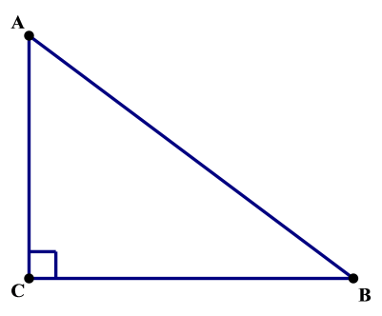
----------------------------------------------------------------------------------------------------------------------------------------------------------------
Solve (find all side lengths and angle measures) the right triangle shown in the figure to the right with the given information:
- A = 20 degrees a = ____________
B = ____________ b = 10
C = ____________ c = ____________

- A = ____________ a = ____________
B = 54 degrees b = ____________
C = ____________ c = 15

- A = ____________ a = ____________
B = 71 degrees b = 24
C = ____________ c = ____________

- A = ____________ a = 6
B = ____________ b = 16
C = ____________ c = ____________

- A = ____________ a = 25
B = ____________ b = ____________
C = ____________ c = 35

- A = $12°15'$ a = ____________
B = ____________ b = ____________
C = ____________ c = 430.5

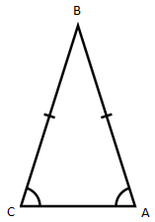
- _____________ Find the altitude of the isosceles triangle.
Round your answer to the nearest thousandths.

A = 52$°$ b = 4 inches

- A ladder 20 feet long leans against the side of a house. The angle of elevation of the ladder is 80 degrees. Find the height from the top of the ladder to the ground.

- From a point 100 feet in front of a public library, the angle of elevation to the base of the flag-pole and the top of the flagpole are $28$ ̊ and $39°45'$ respectively. The flagpole is mounted on the front of the library’s roof. Find the height of the flagpole.

- An engineer erects a 75-foot vertical cellular-phone tower. Find the angle of elevation to the top of the tower from a point on level ground 95 feet from its base.

- A Global Positioning System satellite orbits 12,500 miles above Earth’s surface. Find the angle of depression from the satellite to the horizon. Assume the Earth has a radius of 4000 miles.
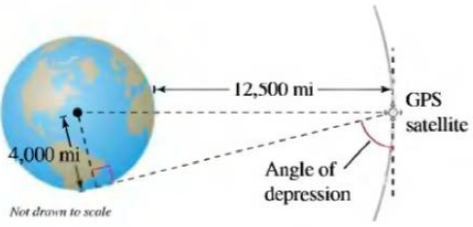

- When an airplane leaves the runway, its angle of climb is $18°$ and its speed is 275 feet per second. Find the plane’s altitude after 1 minute.

- A ship leaves port at noon and has a bearing of $S29°W$. The ship sails at 20 knots. How many nautical miles south and how many nautical miles west will the ship have traveled by 6:00 P.M.?

- A surveyor wants to find the distance across a swamp. The bearing from A to B is $N32°W$. The surveyor walks 50 meters from A, and at the point C the bearing to B is $N68°W$. Find (a) the bearing from A to C and (b) the distance from A to B.
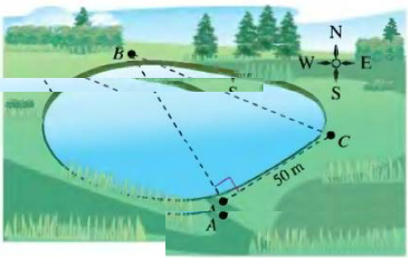
- Two fire towers are 30 kilometers apart, where tower A is due west of tower B. A fire is spotted from the towers, and the bearings from A and B are $E14°N$ and $W34°N$, respectively. Find the distance d of the fire from the line segment AB.
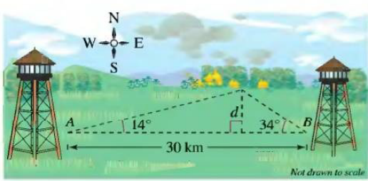

- A ship is 45 miles east and 30 miles south of port. The captain wants to sail directly to port. What bearing should be taken?

