Section 1.1 Precalculus Name ____________________

Worksheet 2 Period _____

Let f(x) = 2x2 – 1

1. Find = 2. Find =

#3-6 Write an equation for each described line. You may write your answer in any one of

the three formats that we have studied.

3. through (-4, 5) and (2, -3) 4. through (-4, 5) and horizontal

5. through (2, - 3) and parallel to y = 2x + 7 6. through (0, 4) and (-3, 0)

7. Write the equation for a direct variation line containing the point .

For the direct variation, find the constant of variation. Then find the value of ***y*** when .

8. 

Accurately graph the following.

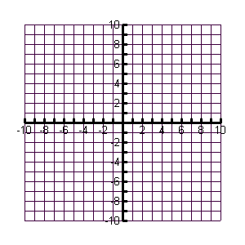

9. 3x – y = 6 10. x = -4

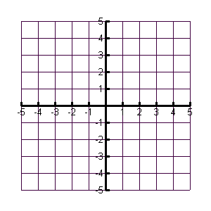11.  12. 

13. Change to slope-intercept form: 14. Change  into a piecewise function



