Unit 2 Tools of Geometry Review part 1 Name__________________

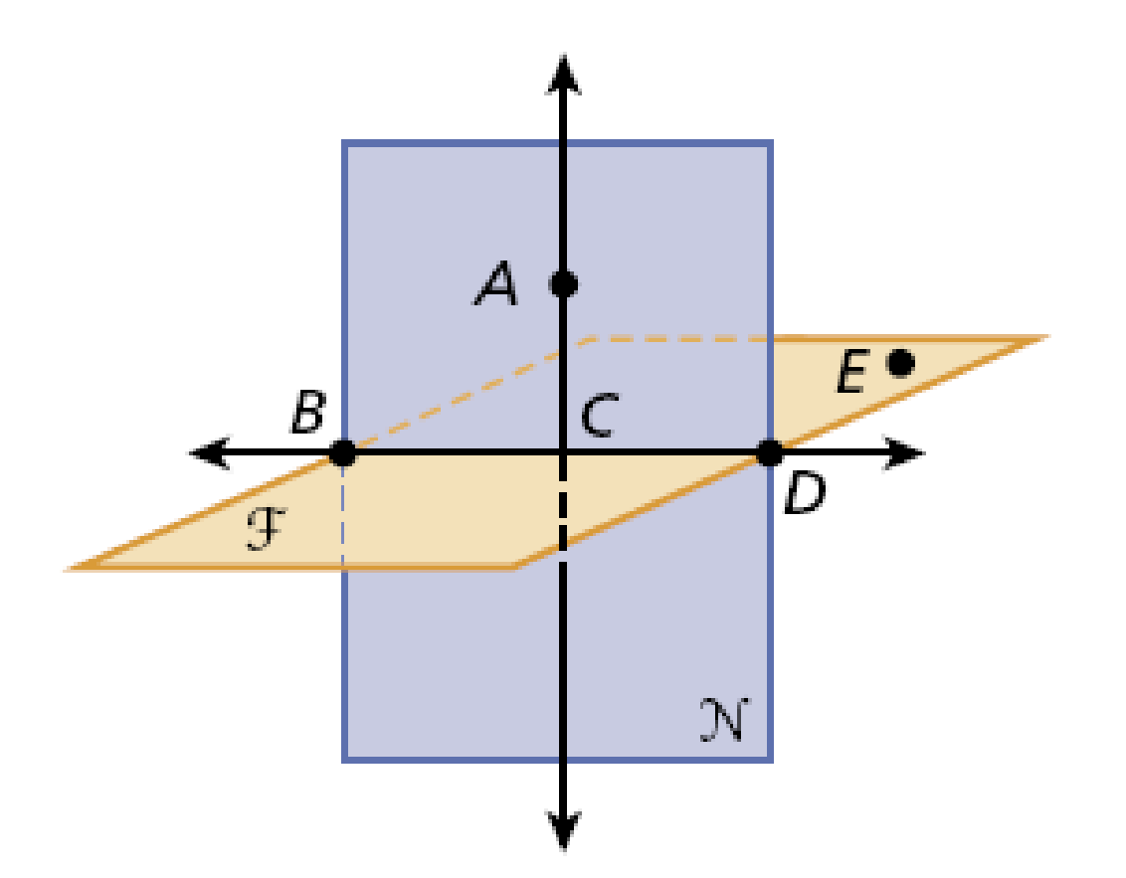
Use the figure to name each of the following.

- five points: _______________
- two lines: ________________
- two planes: _______________
- point on $\vec{AB}$: _____________
- a line in plane F: ___________
- a line that contains A and C _________
- a plane that contains A, D, and C. ______
- three collinear points ______________
- four coplanar points _______________
- a plane containing E _______________

Draw and label each of the following.

- two lines that do not intersect

- a segment with endpoints M and N.

- a line containing X and Y

- pair of opposite rays that both contain R

- a ray with endpoint F that passes through G

- three coplanar lines that intersect in a common point

- B is between A and C, AC = 15.8, and AB = 9.9. Draw a sketch and label the line segment. Find BC.

BC = _____________
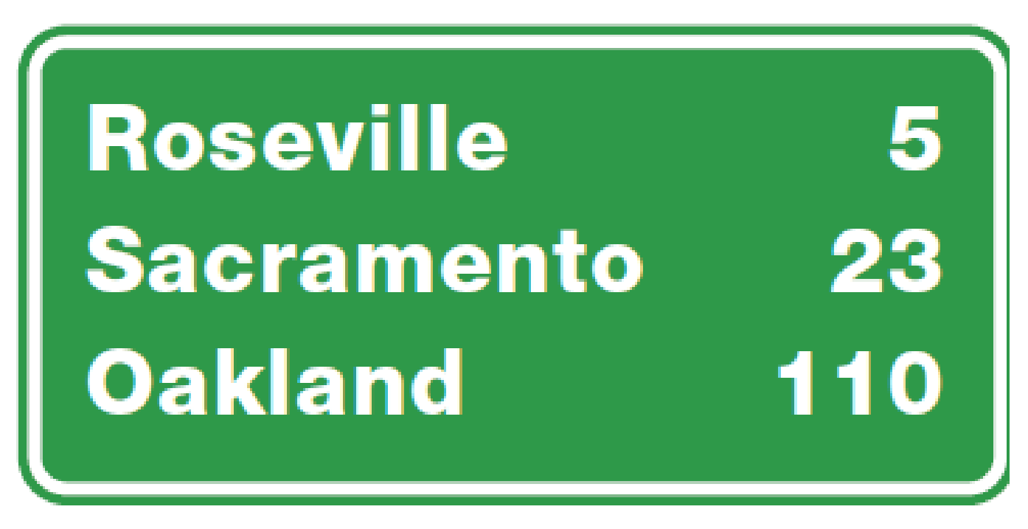
- If a picnic area is located at the midpoint between Sacramento and Oakland, find the distance to the picnic area from the road sign.

Distance to picnic area = ____________________
- K is the midpoint of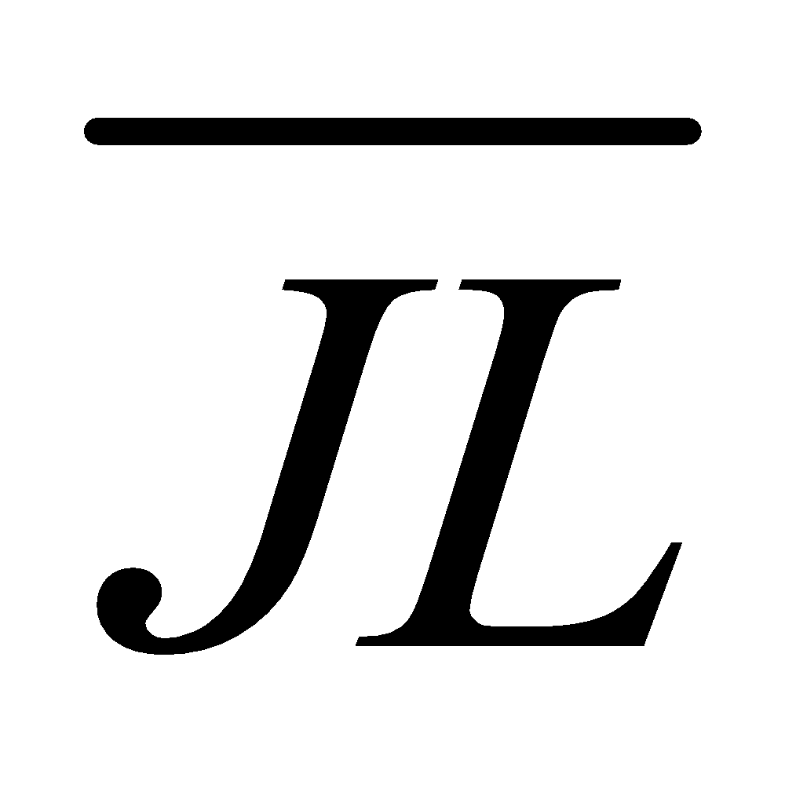, JL = 4x – 2, and JK = 7. Find x, KL, and JL.

x = ___________, KL = _____________, and JL = ______________.
- E bisects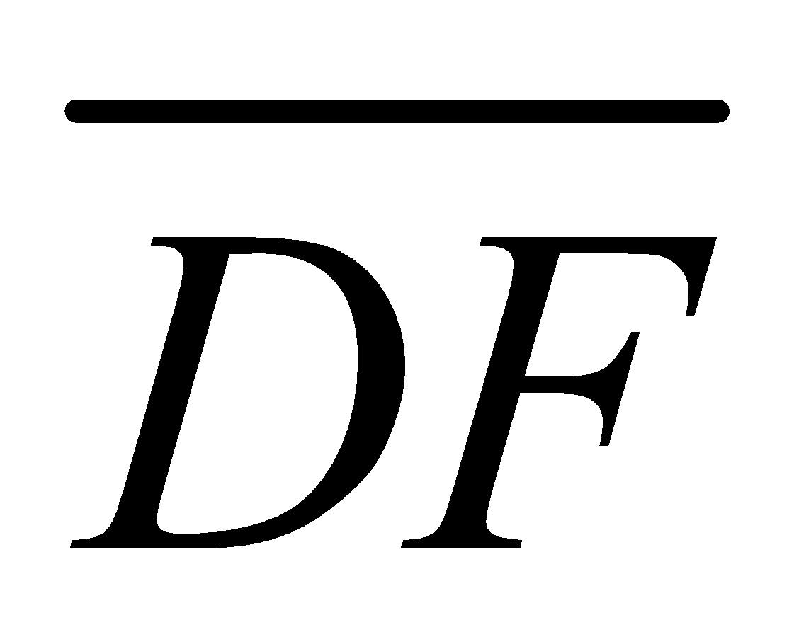, DE = 2y, and EF = 8y – 3. Find DE, EF, and DF.

DE = ___________, EF = _____________, and DF = ______________.
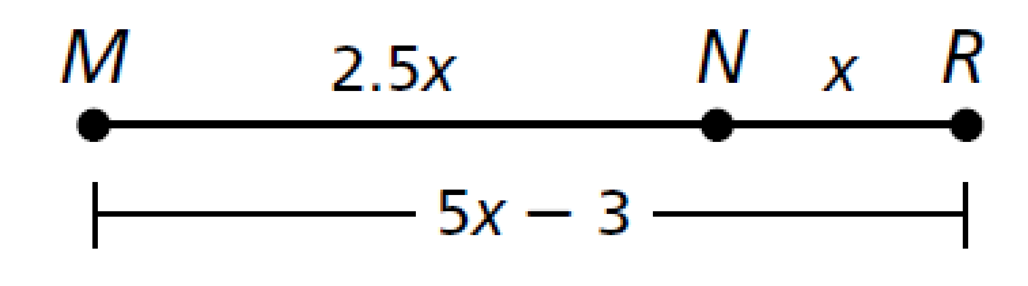
- Find MN. ____________

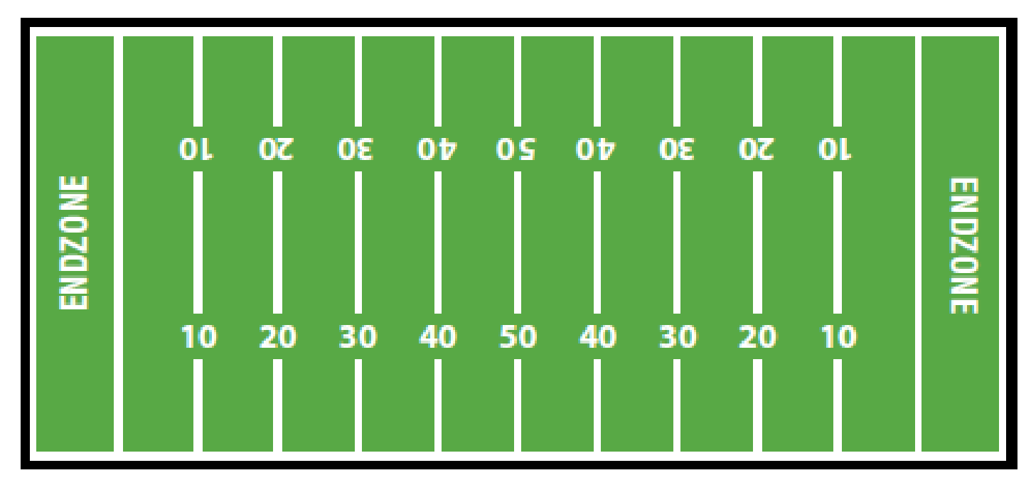
- During a football game, a quarterback standing at the 9-yard line passes the ball to a receiver at the 24-yard line. The receiver than runs with the ball halfway to the 50-yard line. How many total yards (passing plus running) did the team gain on the play?
Yards on the play: ________________

- E is the midpoint of DF, DE = 2x + 4, and EF = 3x – 1. Find DE, EF, and DF.

DE = ___________, EF = _____________, and DF = ______________.
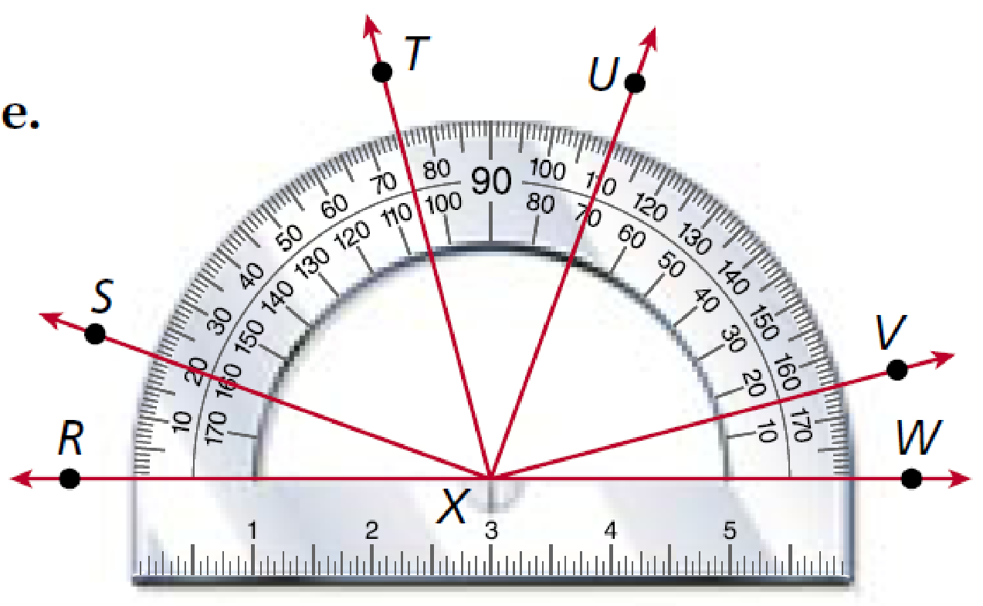
Use the protractor to find the measure of each angle. Then classify each as acute, right or obtuse.
- ∠VXW = _________ _____________________
- ∠TXW = _________ _____________________
- ∠RXU = _________ ______________________

Use the diagram to find the value of x. Please show your work.
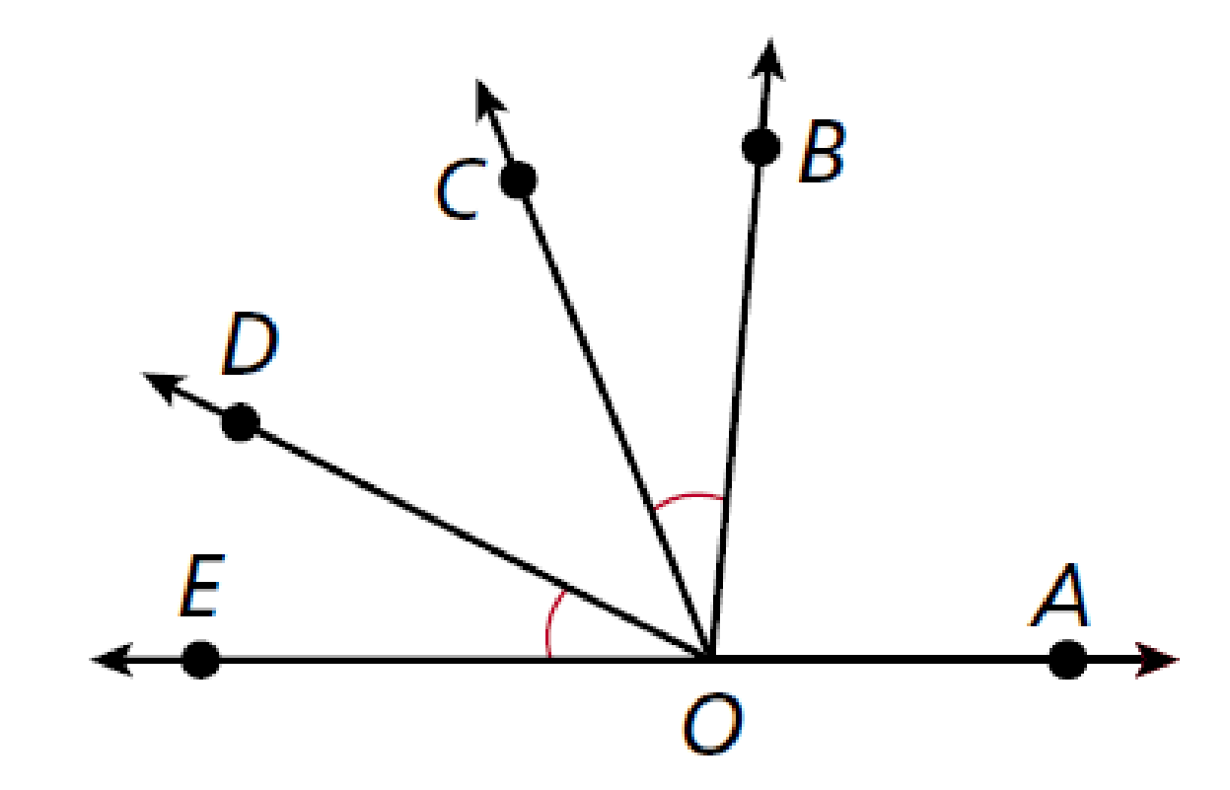
- 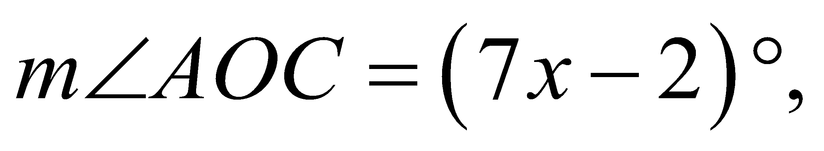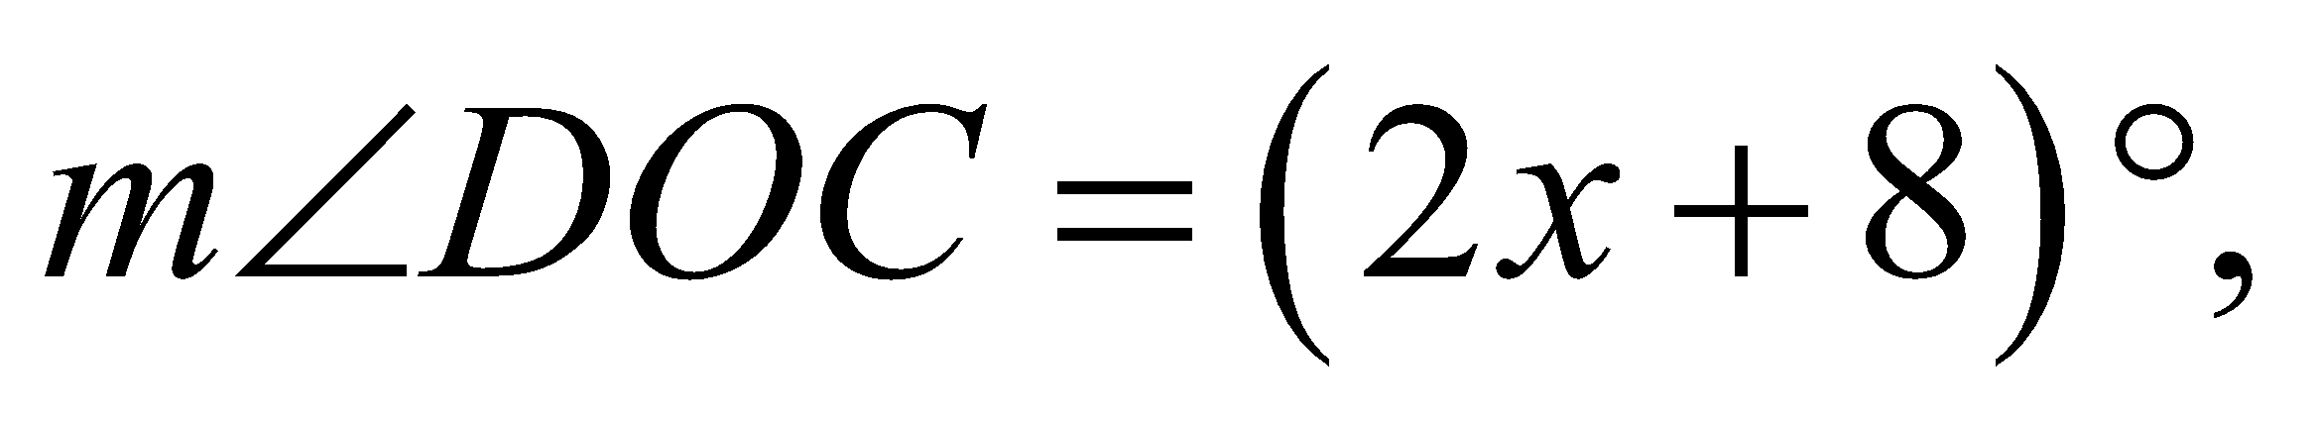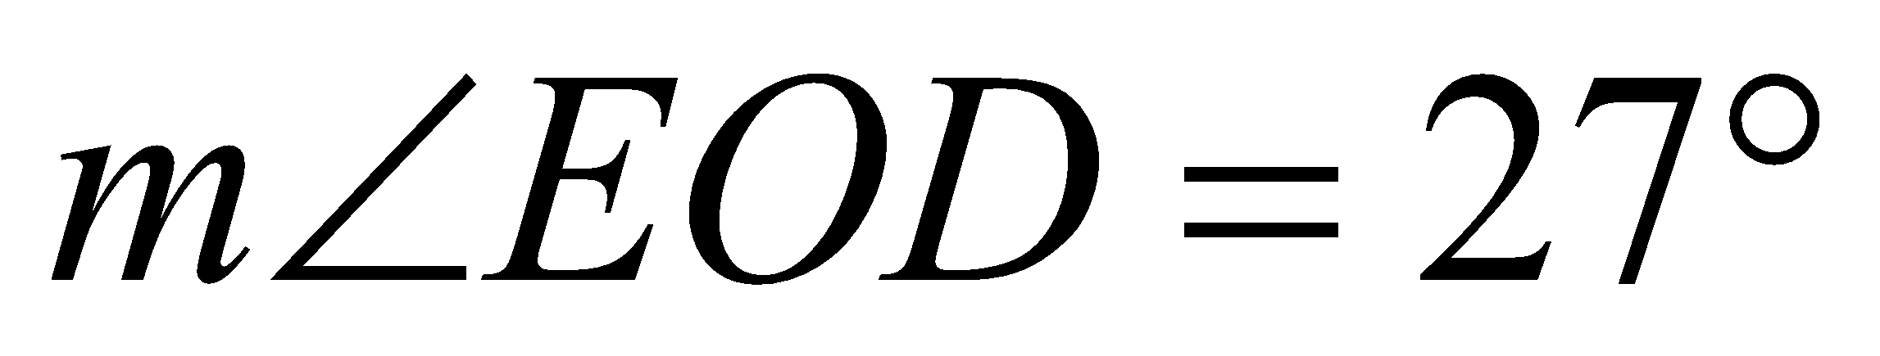

x = _____________

Draw a diagram of each situation, label all parts, find the indicated measure, and show your work.
- $\vec{BD}$ bisects ∠ABC.
  - Find 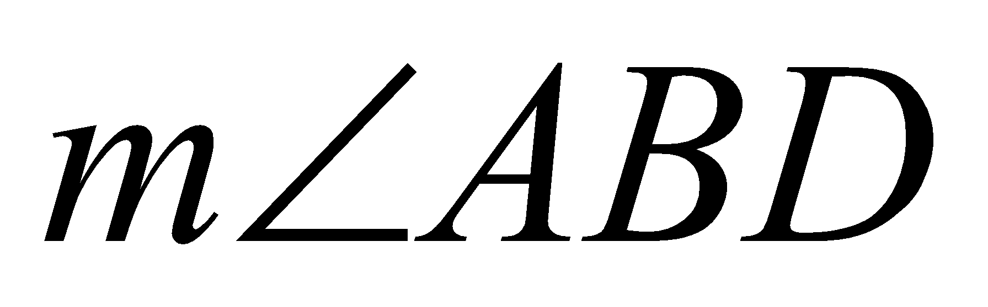 if 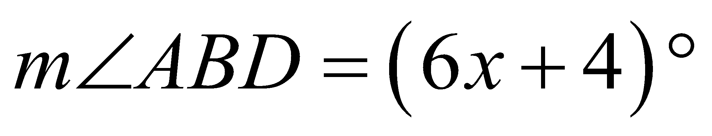 and 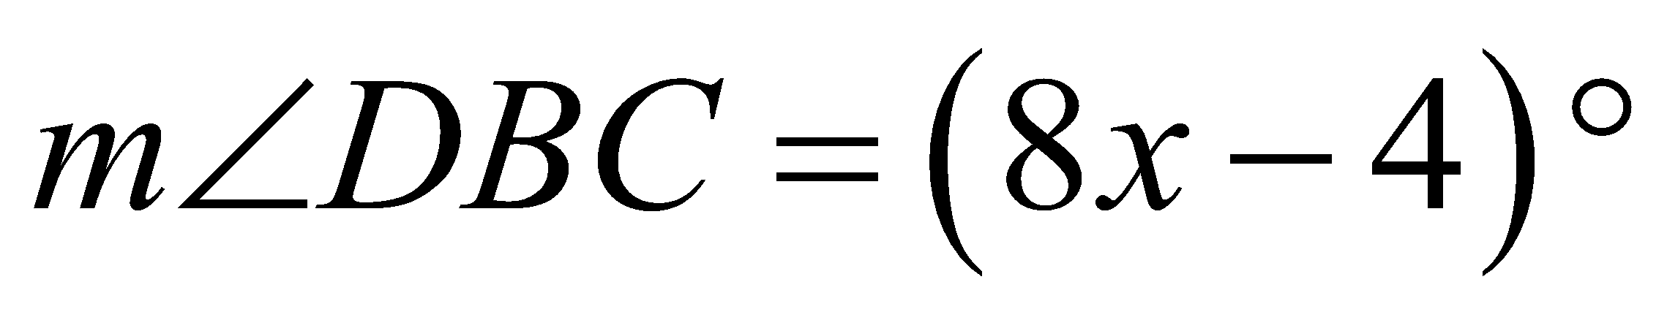. = __________
  - Find 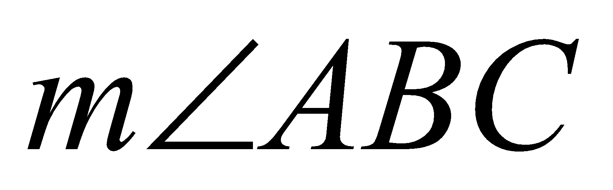 if 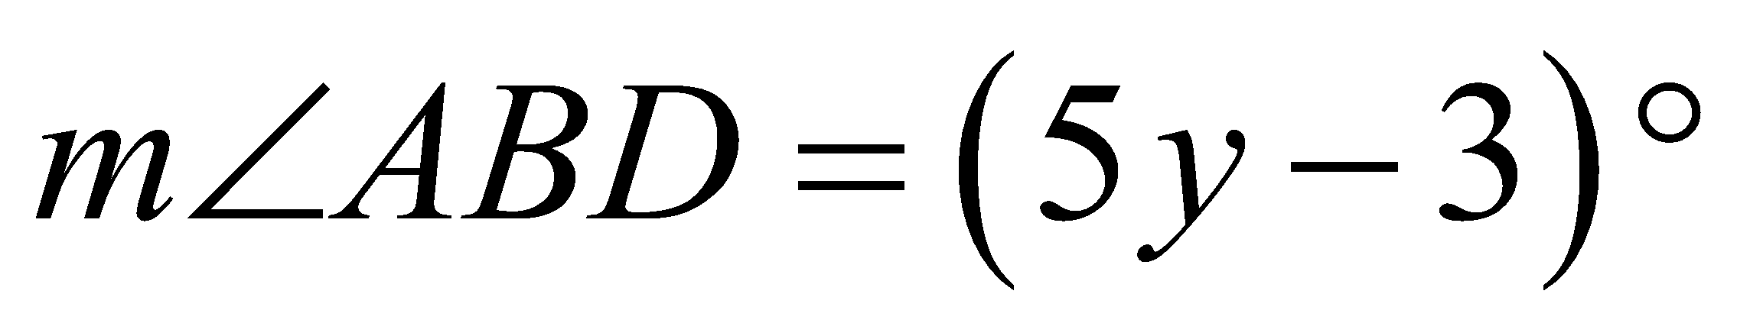 and 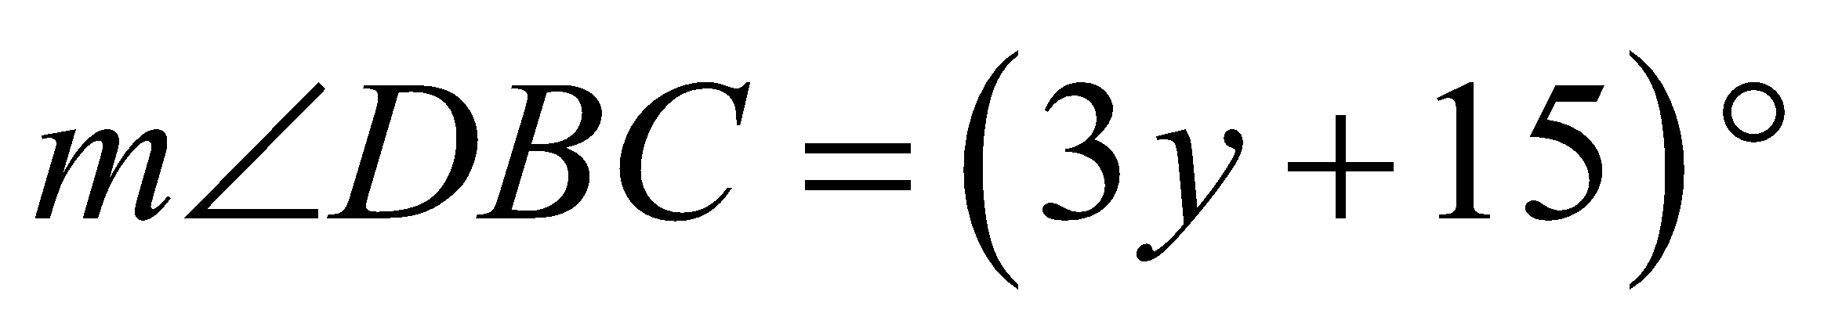. = __________

Tell whether the angles are only adjacent, both adjacent and form a linear pair, or not adjacent.
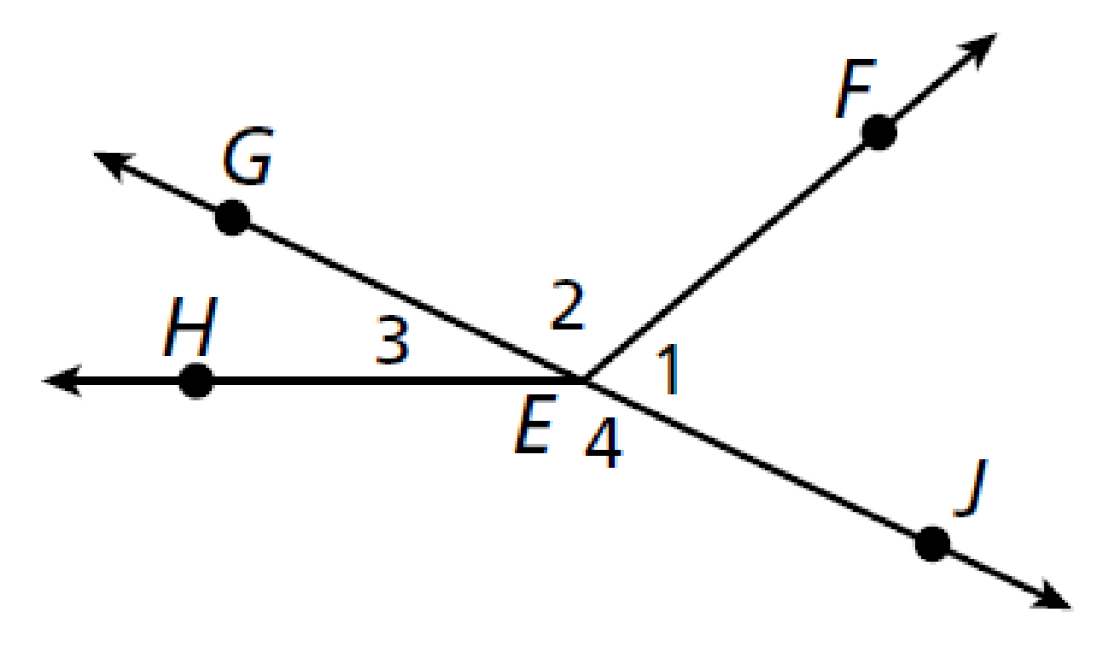
- ∠1 and ∠2 _______________________________
- ∠2 and ∠4 _______________________________
- ∠1 and ∠3 _______________________________
- ∠2 and ∠3 _______________________________
- The angle formed by a tree branch and the part of the trunk above it is 68°. What is the measure of the angle that is formed by the branch and the part of the trunk below it?
Angle measure = ______________
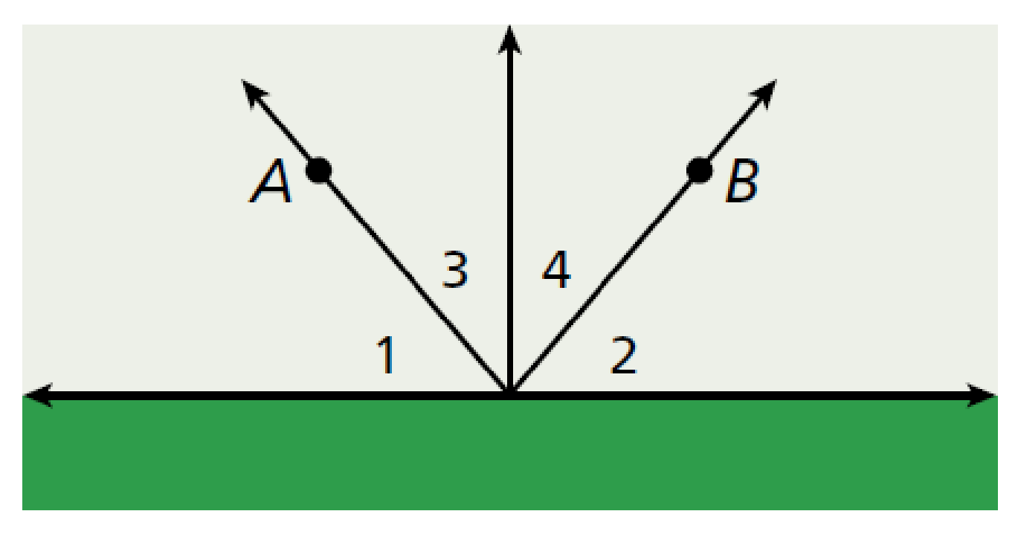
- A sprinkler swings back and forth between A and B in such a way that 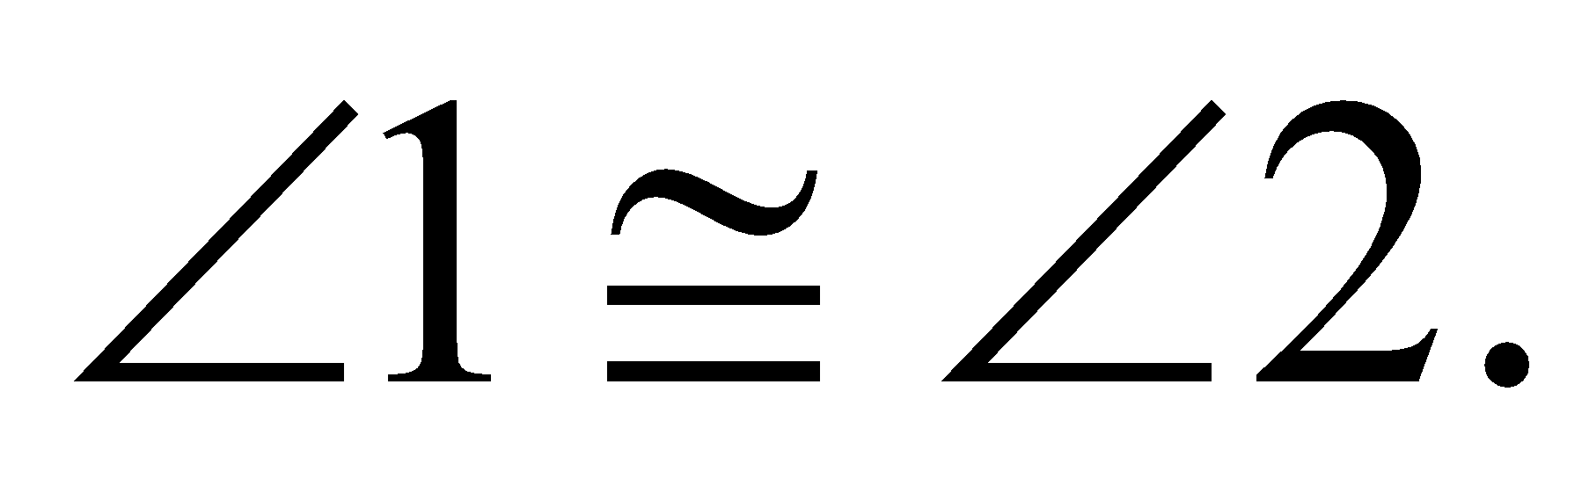 1 and 3 are complementary, and 2 and 4 are complementary. If 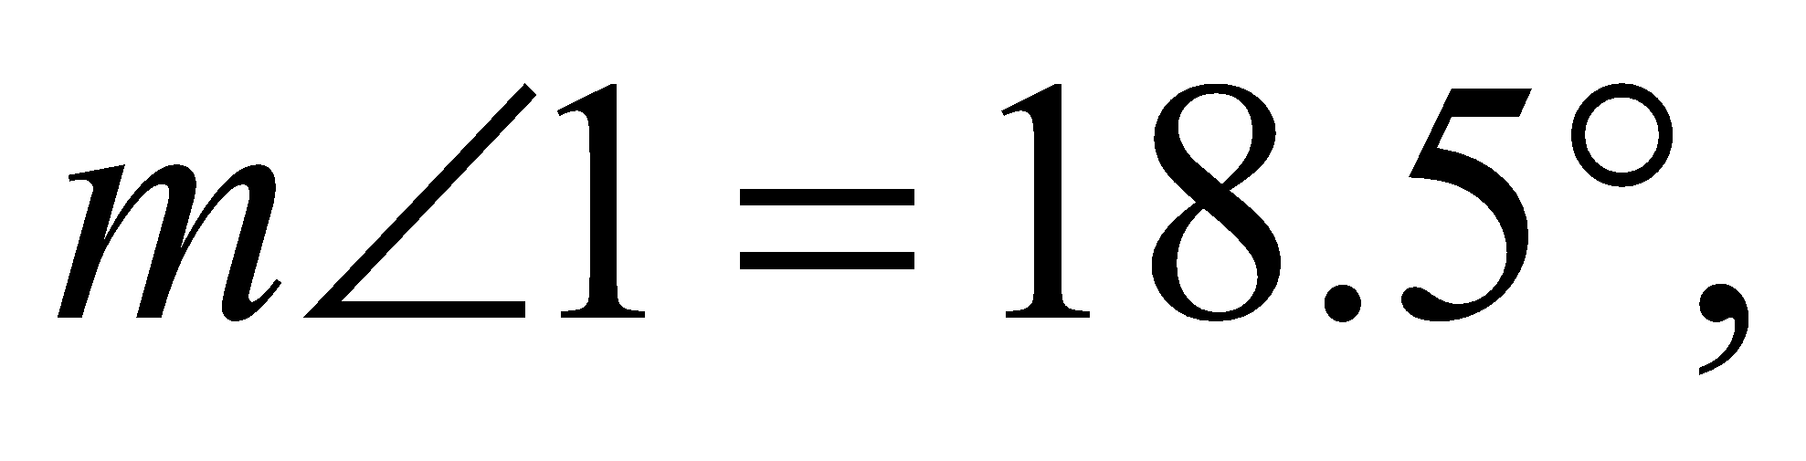 find the following:
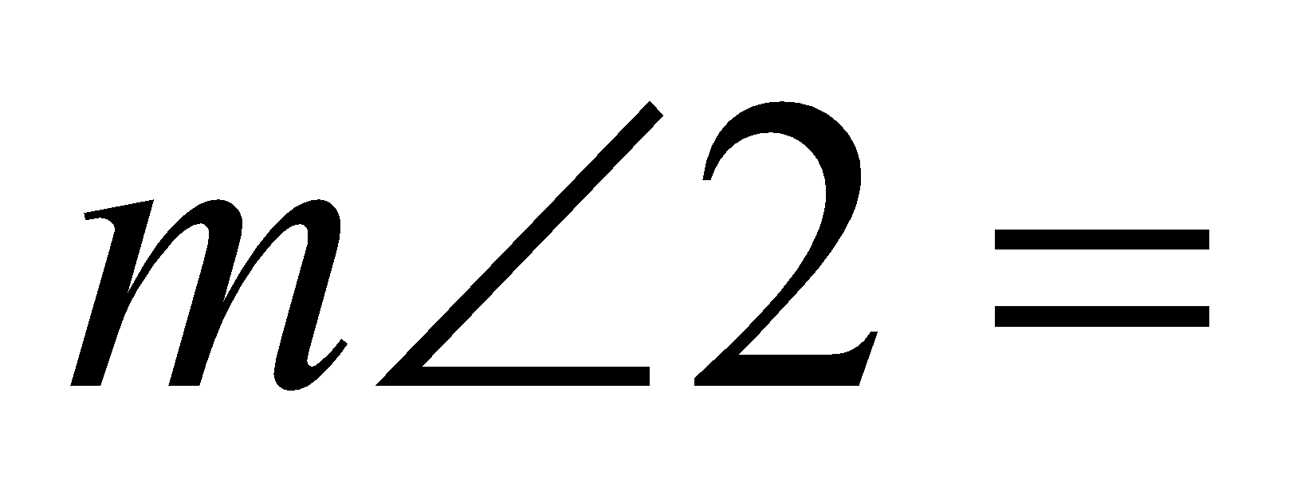 _______________ 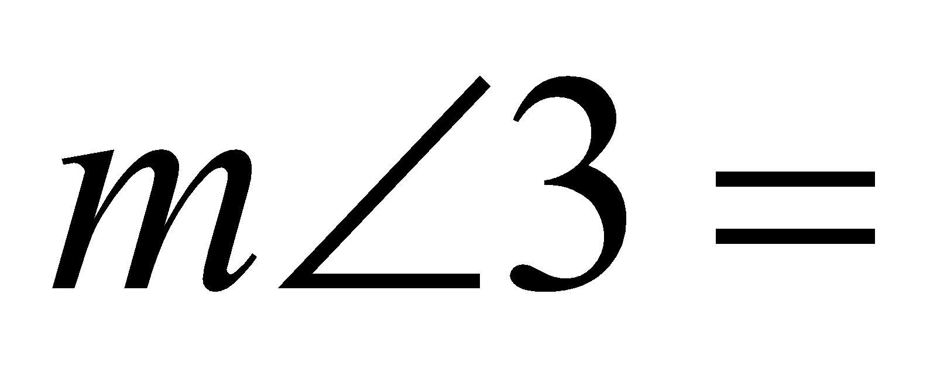 _______________
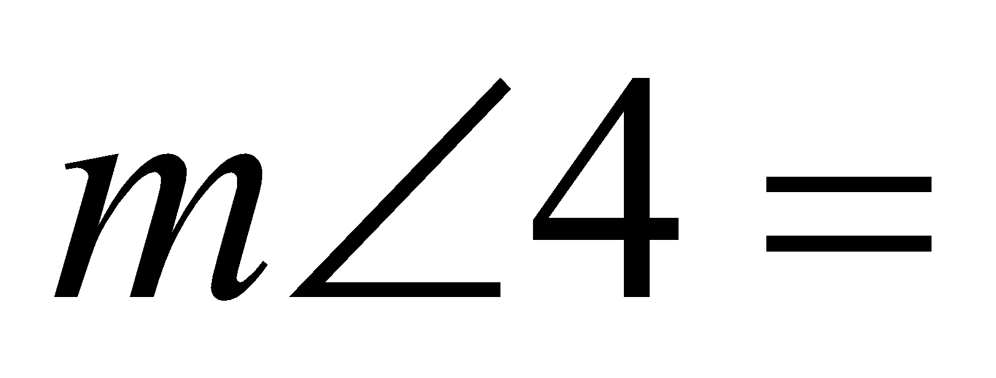 _______________
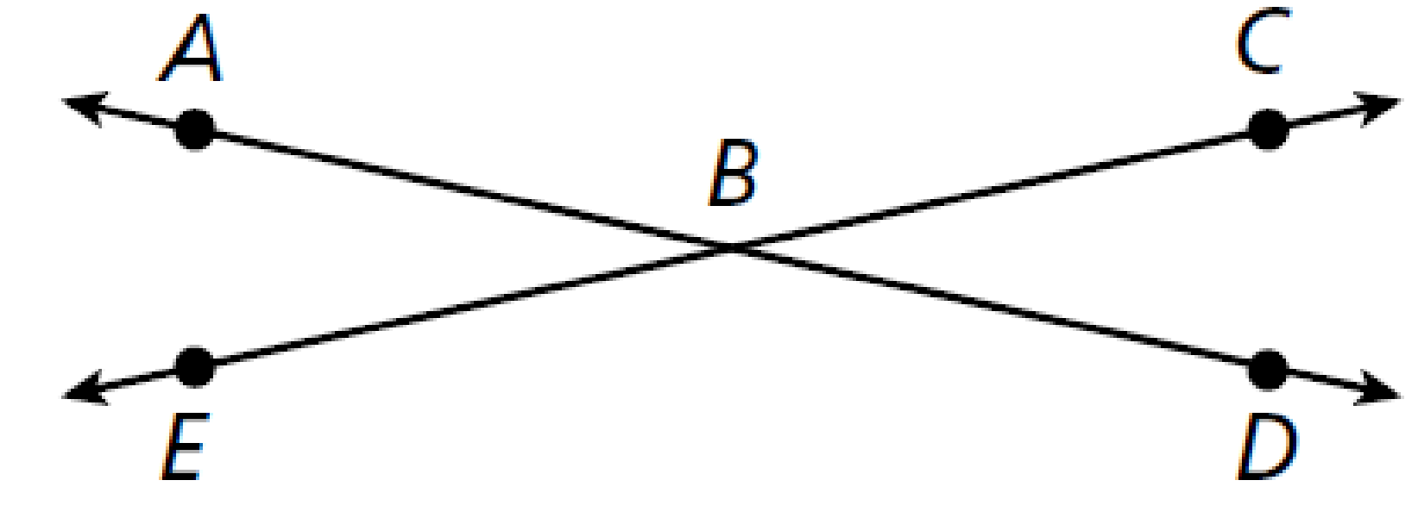
- Name each pair of vertical angles
_______________ and _______________
_______________ and _______________
- ∠ABD and ∠BDE are supplementary angles. Find the measures of both angles if 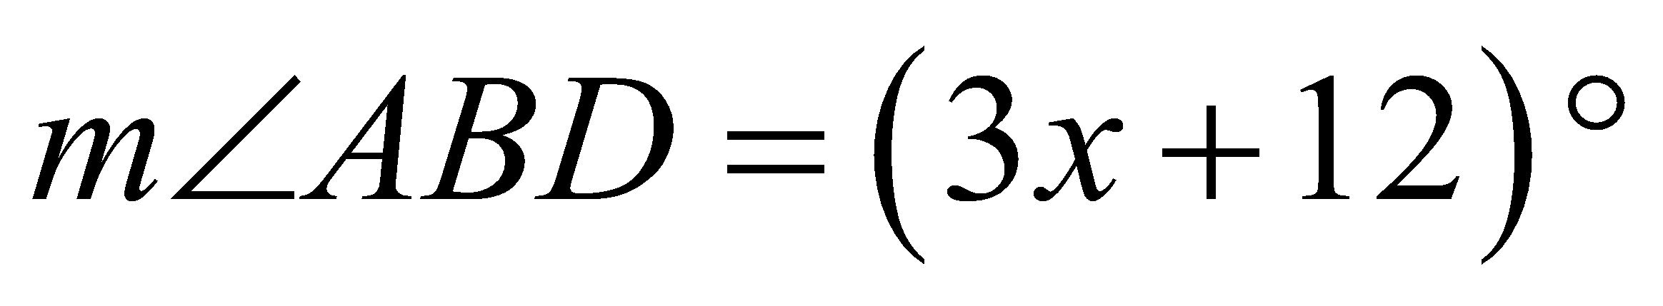 and 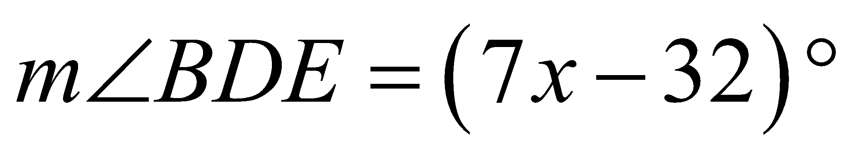.
and

- ∠ABD and ∠BDE are complementary angles. Find the measures of both angles if 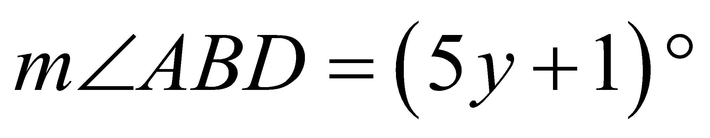 and 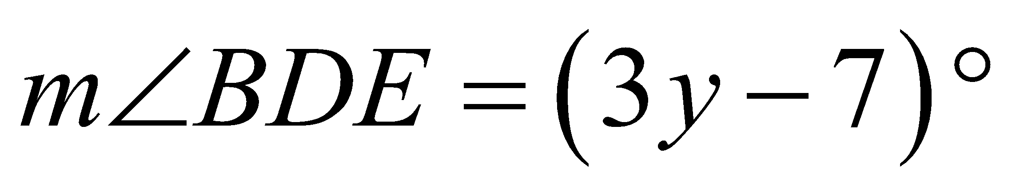. and

Classify the polygon by the number of sides. Tell if the polygon is concave or convex.
38. _________________ 39. ___________________
_________________ ___________________

40. _________________ 41. _____________________
_________________ _____________________

For #42-43, sketch the figure and write an equation to solve the problem,
42. The measure of one angle is 10 less than the measure of its complement. Find the measure of each angle.

43. The measure of one angle is 4 times the measure of its supplement. Find the measure of each angle.

