Section 4.6 Precalculus/Trig Graphs trig functions that are not continuous. Notice location of the vertical asymptotes. Name ________________________

- Y = tan (x)
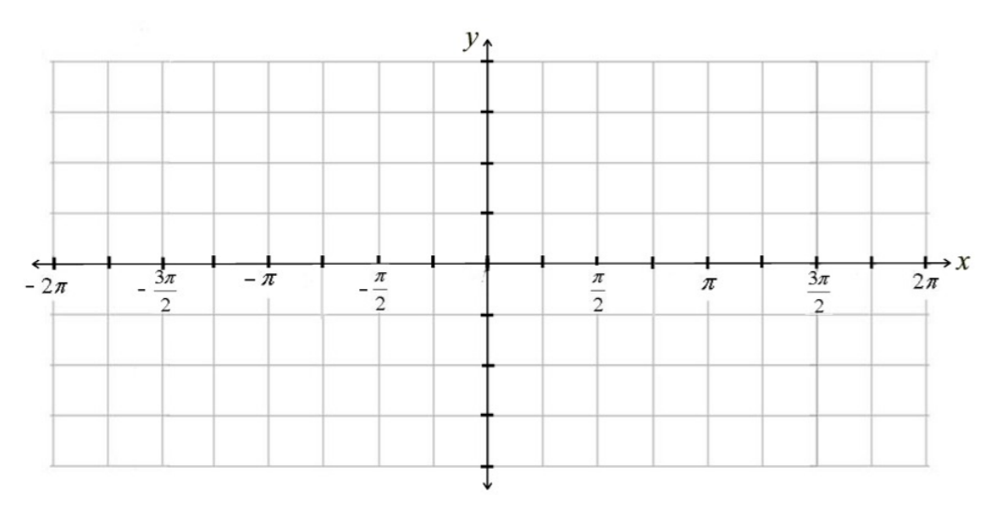

- Y = sec (x)

- Y = cot (x)

- Y = csc (x)

- y = sec (x)

