Homework is to begin the Geometric Truth section of your notebook.
You will need a space of about 20 pages for the year. More if you do not want to write on the backs of pages.
Title the first page as Geometric Truth.
Copy this below your title:
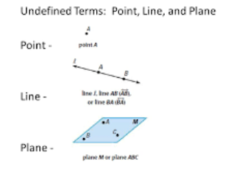
Read pp 24-27 in your new textbook.
Then make your first 6 entries in Geometric Truth, using words and images from these pages.
- Collinear
- Coplanar
- Line segment
- Segment Addition
- Congruent Segments
- Midpoint (use the word “bisect”)
- Ray
An entry looks like:
Term Definition Labeled Sketch
P # in book labels or names for sketch (see point, line, plane above)

