Linear Pairs/ Vertical Angles Practice and Self-Check
In-class section of your notebook: (may just answer; document will be on website)
True or False. Change the false statements to true.
$$\overset{⃡}{AM} intersecting \overset{⃡}{PL } at K$$

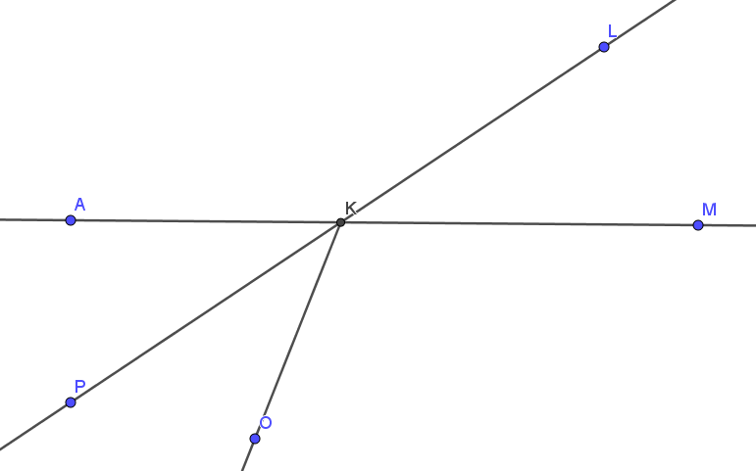

- ∠LKM and ∠MKO are a linear pair.

- ∠JKP ≅ ∠PKO
J

- ∠PKO and ∠OKL are a linear pair.

- ∠JKL and ∠OKM are vertical angles.

- ∠JKP and ∠LKM are vertical angles.

- ∠OKM and ∠MKL are adjacent angles.

- A pair of angles who measure sum to 90° are supplementary angles.

Answers:
- False – change linear pair to adjacent
- False – they are adjacent angles
- True
- False – change ∠OKM to ∠PKM
- True
- True
- False – change 90 to 180 OR change supplementary to complementary

