Name: _____________________________________________ My Semester Exam is: _______________________________________

Fall Semester Exam Review

**Decide whether each “argument” below is inductive or deductive. Write “inductive” OR “deductive” and a reason for your choice. If inductive, give the conjecture and a counterexample.**

1. The American League has won the World Series for the last several years. Therefore, the American League will win the World Series this year.
2. Janie has Geometry 6th period, therefore she does not have PreAP Science 6th period.
3. Every time I measure the three angles in a given triangle, they add up to 180 degrees. Therefore, the sum of the three angles of any triangle is 180 degrees.
4. For square ABCD, side AB has a length of 10 cm. For square WXYZ the perimeter is 40 cm. Therefore, square WXYZ also has a side length of 10 cm.
5. “Sir, my client has a parking ticket placed on his car on the square in Fayetteville dated 8/06/2015 at 10:15 am. Therefore, my client could not have hit your car with his in the parking lot at the NWA Mall at 10:10 am on 8/06/2015.”
6. Every time I check the Chicago River near my office in downtown Chicago, it is running northeast past my building. Therefore, the Chicago River cannot reverse direction and run southwest past my building.
7. For the following statement give its converse, inverse, and contrapositive. State whether each is true. Assume the original statement is true.

If two angles are vertical angles, then they are congruent.

1. *E* bisects, *DE* = 2*y*, and *EF* = 8*y* – 3. Find *DE*, *EF*, and *DF*.

*DE* = ___________, *EF* = _____________, and *DF* = ______________.

1. *E* is the midpoint of DF, *DE* = 2*x* + 4, and *EF* = 3*x* – 1. Find *DE*, *EF*, and *DF*.

*DE* = ___________, *EF* = _____________, and *DF* = ______________.

**Draw and label each situation. Find the indicated parts.**

1.  bisects ∠*ABC*.
   1. Find  if  and .  = __________
2. ∠*ABD* and ∠*BDE* are a linear pair of angles. Find the measures of both angles if  and .

 and 

1. ∠*ABD* and ∠*BDE* are complementary angles. Find the measures of both angles if  and .  and 
2. 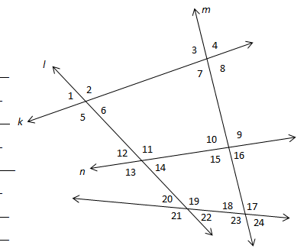 ___________________________
3. ___________________________
4. ___________________________
5. ___________________________
6. ___________________________
7. ___________________________
8. ___________________________
9. ___________________________

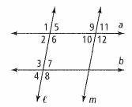

1. Use the figure at the right and the given information to determine

which lines are parallel.

$∠6$ is supplementary to $∠7$

$∠5≅∠7$

**Use the figure at the right to answer questions 22-25.**

1. Which angle must be congruent to $∠2$ in order for lines *m* and *n* to be parallel? Explain.

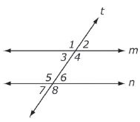

1. Which angle must be supplementary to $∠2$ in order for lines *m* and *n* to be parallel? Explain.
2. What must be known about $∠1$ and $∠8$ in order for the lines *m* and *n*  to be parallel?
3. What must be known about $∠3$ and $∠5$ in order for lines *m* and *n* to be parallel?
4. 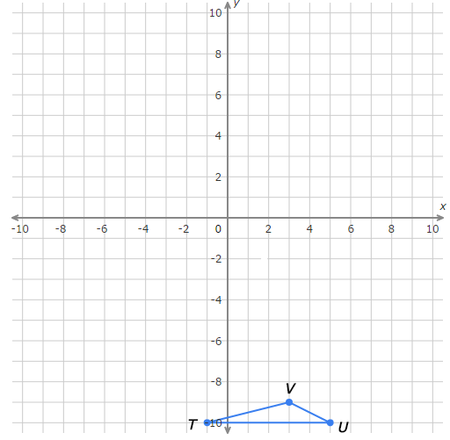translate $(x, y)→(x-6, y+6)$
5. 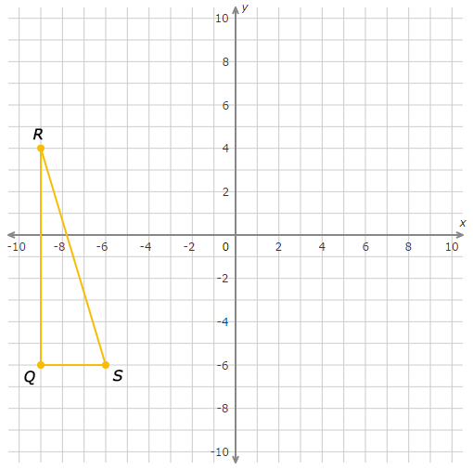rotate 270o counterclockwise about (0, 0)
6. 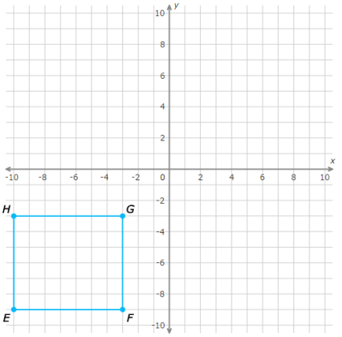reflect across the y-axis
7. 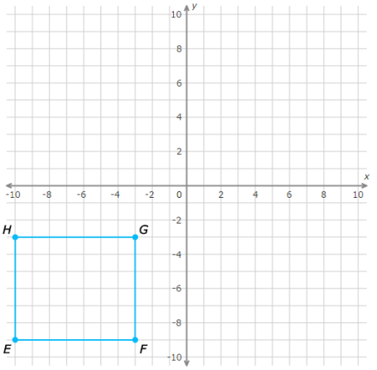reflect across the line $x=-2$