HW#12 Solving Word Problems Practice

1. Samuel is at the top of a tower and will ride a trolley down a zip line to a lower tower. The total vertical drop of the zip line is 40 ft. The zip line’s angle of elevation from the lower tower is 11.5°. What is the horizontal distance between the towers? Show your work.

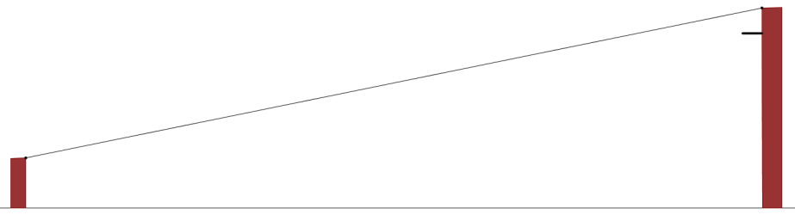

2. During a flood relief effort, a Coast Guard patrol boat spots a helicopter dropping a package near the Florida shoreline. The crew on the boat measures the angle of elevation to the helicopter to be 15° and the distance to the helicopter to be 6800 meters. How far is the patrol boat from the point where the package will land? Draw a sketch to support your answer and show your work.

3. Scott, whose eye level is 1.5 m above the ground, stands 30 m from a tree. The angle of elevation of a bird at the top of the tree is 36°. How far above ground is the bird? Show your work.

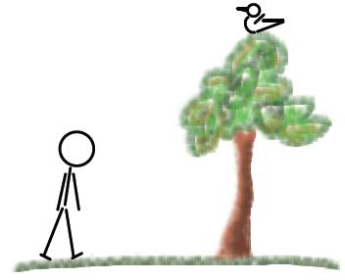

4. From an angle of depression of 40°, John watches his friend approach his building while standing on the rooftop. The rooftop is 16 m from the ground, and John’s eye level is at about 1.8 m from the rooftop. What is the distance between John’s friend and the building? Show your work.

5. Standing on the deck at the top of a lighthouse, a person spots a ship at an angle of depression of 20°. The lighthouse is 28 m tall and sits on a cliff 45 m tall as measured from sea level. What is the horizontal distance between the lighthouse and the ship? Sketch a diagram to support your answer and show your work.

