Unit 6: Dilations & Similarity Name _______________________________Period___

Test Review

1. A 5-foot man standing next to a flagpole casts a 4-foot shadow. At the same time, the flag-pole casts a shadow of 18 feet. What is the height of the flagpole? (Round to the nearest whole number.)
2. The two triangles below are similar. What is the similarity ratio?

12

15

9

10

6

8

1. Which theorem or postulate proves the triangles are similar? Write the similarity statement.

70°

**A**

12

**G**

**U**

16

70°

15

20

**E**

**F**

**B**

$∆BEF \sim ∆ __________$

1. In the similar triangles shown, what is the value of x?

x

9

4

8

6

6

1. Let P(3, 6) be a point on a figure, and let P’ be the corresponding point on the image. The figure is dilated by a scale factor of 3. What are the coordinates of P’?
2. 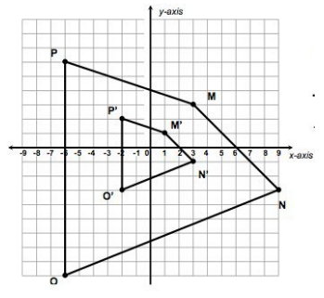In the diagram, quadrilateral M’N’O’P’ is the image of quadrilateral MNOP after a dilation. What is the scale factor?
3. 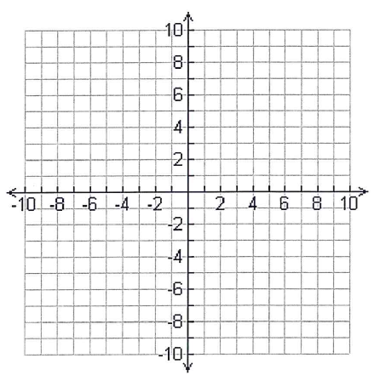 Graph A(3, 6), B(6, 3), and C(0, 9). Then graph the dilated image of triangle ABC using a scale factor of 2/3 and the origin as the center of dilation.

A’ _______________

B’ _­______________

C’ _______________

|  |  |
| --- | --- |
| **Given: $\overline{BD}∥\overline{AE}$**  **Prove: $△ACE∼△BCD$** |  |
| **Statements** | **Reasons** |
| 1. | 1. |
| 2. | 2. |
| 3. | 3. |
| 4. | 4. |
| 5. | 5. |



|  |  |
| --- | --- |
| **Given: $\overline{QM}∥\overline{OP}$**  **Prove: $△QMN∼△OPN$** |  |
| **Statements** | **Reasons** |
| 1. | 1. |
| 2. | 2. |
| 3. | 3. |
| 4. | 4. |
| 5. | 5. |