To help recognize SAS shortcut, look at 10, 11, 16, and 18. Answers to 16-18 are at the bottom.

#10, angle not #11 APR by SAS ignore #12
Between sides
#13 – ignore #14 – ignore #15 - ignore

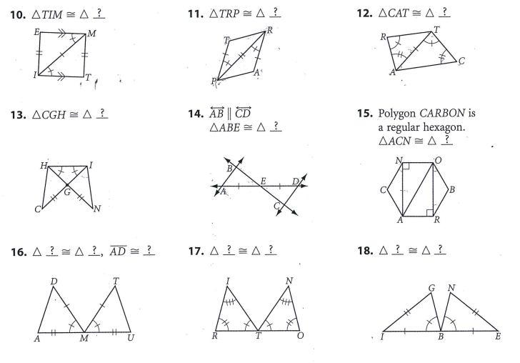

#16 - ∆DAM ≅ ∆TUM by SAS 17. Ignore 18. – angle not between sides

