Congruent Polygons Definition

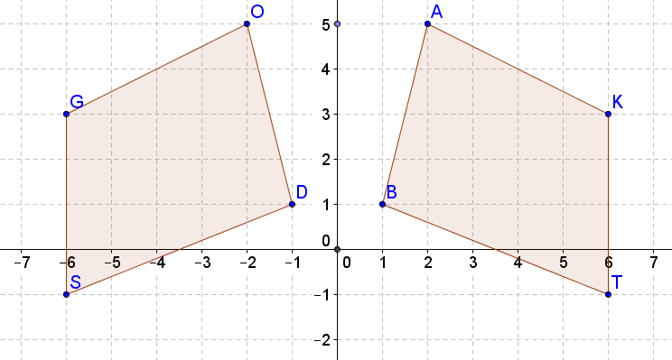

1) Quadrilateral DOGS is a _____________________ of quadrilateral BAKT across

__________________________. DOGS is/is not the same size and shape as BAKT

because it is a ____________ transformation.

2) Side BA corresponds to side _________. Side DS corresponds to side _______.

3) ∠G corresponds to ________. 4) ∠T corresponds to ___________.

5) Corresponding sides are ______________________.

6) Corresponding angles are __________________________.

Congruent polygons are polygons that have corresponding sides congruent and corresponding angles congruent.

Another definition: Polygons are congruent if, by one or a series of rigid transformations, you can map one of the polygons exactly onto the other one.

Explain why BAKT ≅ DOGS:

