HW #1 - write the coordinates next to each labeled point in the two figures below.
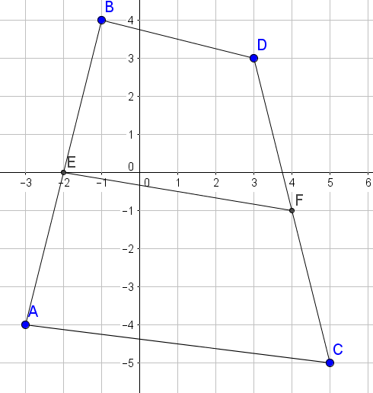
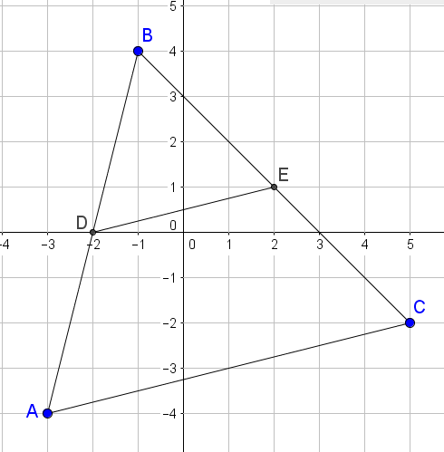

Prove that DE is a midsegment using midpoint Prove that EF is a midsegment using
formula. midpoint formula.

Find the slopes of DE and AC by counting Find the slopes of EF and AC by counting
rise/run. Explain why DE is parallel to AC. rise/run. Explain why EF is parallel to AC.

Use distance formula to find the length of Use distance formula to find the lengths of
DE and AC. Round to hundredths. Is DE half BD, EF, and AC. Show that EF is half the
the length of AC? sum of BD and AC.

