Fayetteville High School Compass Order Form August 2018

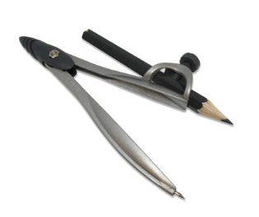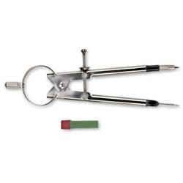

Name_______________________________

Teacher________________Period________

Cost: $1.50 – cash only Date received_________

Due by: August 27, 2018 at the latest!

Fayetteville High School Compass Order Form August 2018



Name_______________________________

Teacher________________Period________

Cost: $1.50 – cash only Date received_________

Due by: August 27, 2018 at the latest!

Fayetteville High School Compass Order Form August 2018



Name_______________________________

Teacher________________Period________

Cost: $1.50 – cash only Date received_________

Due by: August 28, 2017 at the latest!

Fayettville High School Compass Order Form August 2018



Name_______________________________

Teacher________________Period________

Cost: $1.50 – cash only Date received_________

Due by: August 28, 2018

at the latest!