Add to Geometric Truth
Definitions:
P 147 – segment bisector
Copy definition and labeled sketch from p 147
Perpendicular bisector
Copy sketch from p 147. Definition: a line passing through the midpoint of a line segment at a right angle
P 149 – median
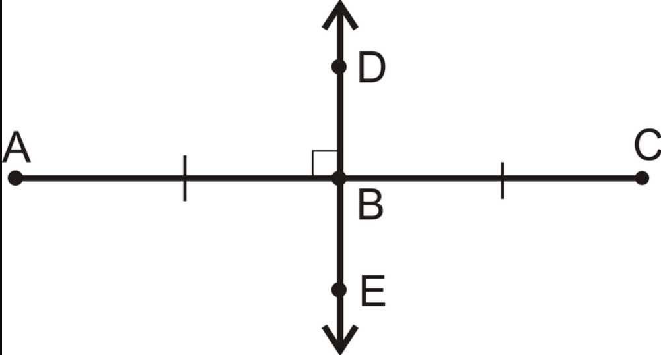
P 149 – midsegment
For median and midsegment, copy definition and sketch from p 149
C-5 – Perpendicular Bisector Conjecture
P 148 – If a point is on the perpendicular bisector of a segment, then it is ??? from the endpoints of the segment.
C-6 - Converse of Perpendicular Bisector
P 149 – If a point is equidistant from the endpoints of a segment, then it is on the ??? ???? of the segment.

