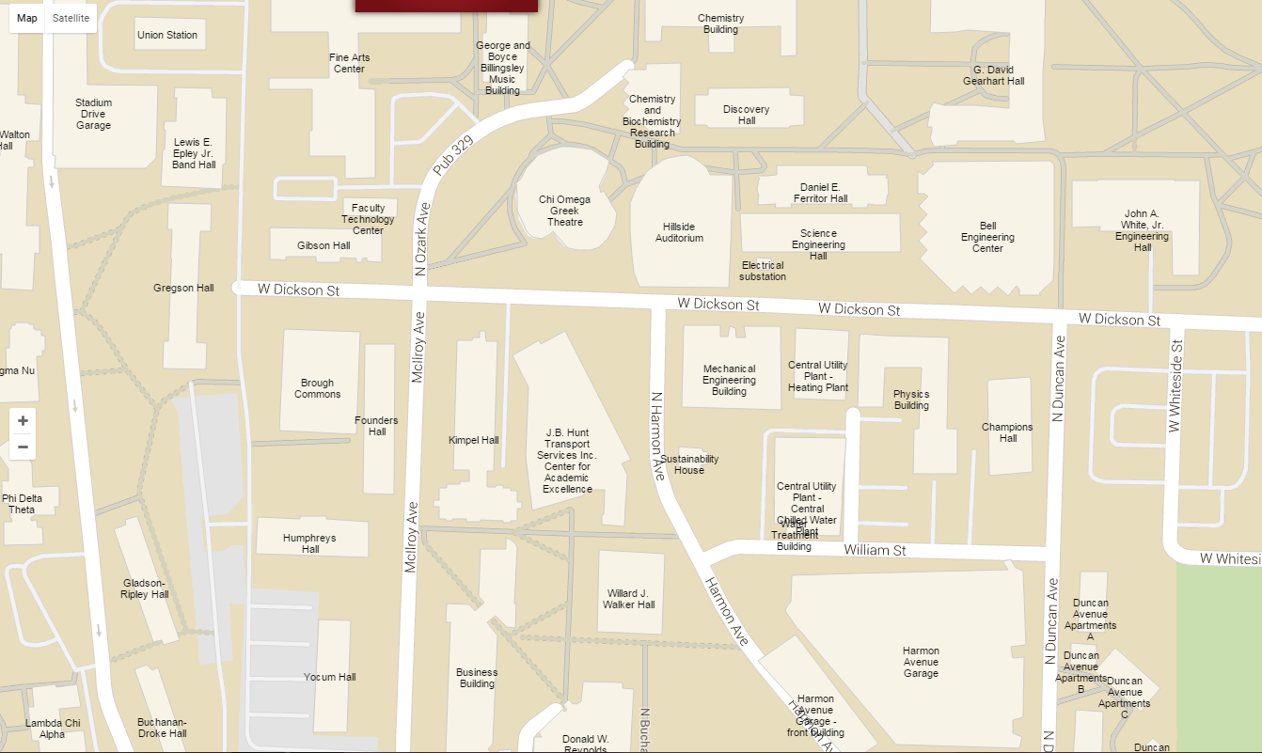

Park  
Free  
Here

Walton  
Arts  
Center