My Geometric

Book Of Constructions

Copying Segments and Angles
The ____________________ and ____________________ are the tools used for geometric constructions.
- Draw a segment with the straightedge that is longer than the given segment.

- Label the endpoints

- On the original segment, set your compass to the width of the segment (endpoint to endpoint)

- Swing a small arc
(Do not change width of compass)

- Place end of compass on one endpoint of the new segment

- Swing same arc as Step 4

- Label the endpoints

Copying a Segment

- Draw a ray that is longer than the given ray.

- Label the endpoint (future vertex)

- Copy the bottom segment or ray on the original angle and swing an arc on new ray

- Place end of compass on point C of original angle. Adjust the width to meet point A and swing an arc. (You are measuring the width of the angle using the compass)

- Swing same arc as Step 4 on new angle

- Use straightedge to connect the vertex with the intersection of the two arcs.
Copying an Angle
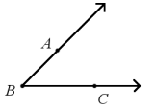

Copying Segments and Angles
Practice another angle

Adding/Subtracting/Multiplying Segments

Constructing Perpendicular Bisectors
Each segment in a plane has only ____________________ bisector that is also ____________________ to the segment. This line is called a ____________________ ____________________.

Sketch:

Constructing a Perpendicular Bisector
- Draw a segment and label the endpoints.

- Put compass on one endpoint and open the width to more than half of the segment.

- Swing arcs above and below the segment.
(Do not change the width of the compass)

- Repeat Step 3 from other endpoint.

- Draw a line through the intersection of both arcs

- Label 90 degree (square box) and tick marks.

Perpendicular Bisector Conjecture: If a point is on the perpendicular bisector of a segment, then it is ____________________ from the endpoints.
Converse of Perpendicular Bisector Conjecture: If a point is equidistant from the endpoints of a segment, then it is on the ____________________ ____________________ of a segment.
Constructing Perpendicular Bisectors
TRIANGLES
The ____________________ is a segment connecting the vertex of a triangle to the midpoint of its opposite side. Every triangle has ____________________ medians.
Constructing a Median
- Choose the side of the triangle you want to bisect

- Follow the steps for Constructing a Perpendicular Bisector

- Mark the midpoint and label the segment with markings

- Connect the midpoint to the opposite vertex.

The ____________________ is a segment that connects the midpoints of two side of a triangle.
Every triangle has ____________________ midsegments.
Sketch

Constructing Angle Bisectors
An __________________ __________________ divides an angle into two __________________ angles.
Constructing an Angle Bisector
- Draw an angle.

- Place the end of the compass on the vertex. Open the width and swing an arc that intersects both rays of the angle.

- Label the new points.

- Place compass on one of the new points and swing an arc in the middle of the original angle.

- Keep the compass setting the same and draw a similar arc from the other new point.

- Draw a ray from the vertex of the original angle to the intersection of the arcs.

- Label the new congruent angles.

Angle Bisector Conjecture: If a point is on the bisector of an angle, then it is ____________________ from the sides of the angle.

Example
Construct an equilateral triangle and bisect one of the vertices.

Constructing Perpendiculars to a Line
Constructing a Perpendicular from a point to a line
- Draw a line and a point P not on the line.

- Put end of compass on point P and open the width until it touches the line (at an angle)

- Swing a “smiley face” arc that intersects the line twice

- Use the intersections of the arc as the endpoints of a new line segment and construct a perpendicular bisector.

- Draw a line connecting the perpendicular bisector through the point P.

- Label: endpoints, midpoint, 90 degree square, and tick marks.

Shortest Distance Conjecture: The shortest distance from a point to a line is measured along the ____________________ ____________________ from the point to the line.

Constructing Perpendiculars to a Line
TRIANGLES
The ____________________ is a perpendicular segment from a vertex to the opposite side or to a line containing the opposite side. The length of the altitude is the ____________________ of the triangle.
Every triangle has ____________________ altitudes.
- Use the base of the triangle and the vertex opposite the base as the point not on the line.

- Put end of compass on that vertex and open the width until it touches the base (at an angle)

- Swing a “smiley face” arc that intersects the base twice

- Use the intersections of the arc as the endpoints of a new line segment and construct a perpendicular bisector.

- Draw a line connecting the perpendicular bisector through the vertex.

- Label

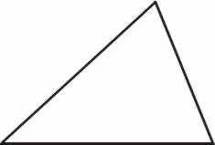
Obtuse Triangle
Right Triangle

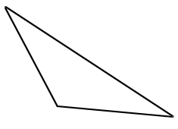

Points of Concurrency

The _______________________ is the point where the 3 ___________________ ___________________ intersect. The incenter is the center of the triangle’s incircle – the largest circle that will fit inside the triangle and touch all three sides.
The triangle’s incenter is __________________________________ the triangle.
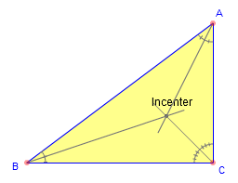
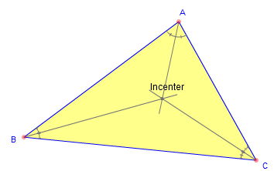
Incenter Conjecture: The incenter of a triangle _____________________________________________.

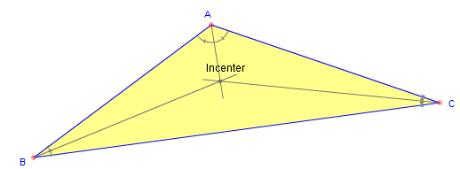

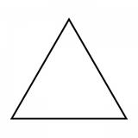
Equilateral Triangle

Points of Concurrency
The _______________________ is the point where the 3 _______________________ _______________________ intersect. The circumcenter is also the center of the triangle’s circumcircle – the circle that passes through all three of the triangle’s vertices (outside the triangle).
Circumcenter Conjecture: The circumcenter of a triangle _______________________________________________________________________.
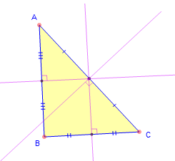
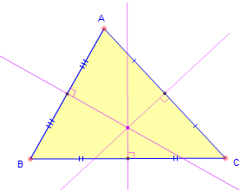

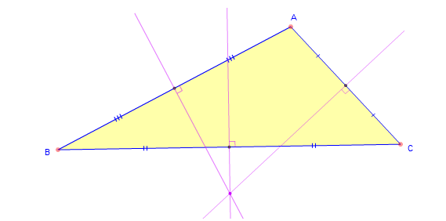

Equilateral Triangle

Points of Concurrency
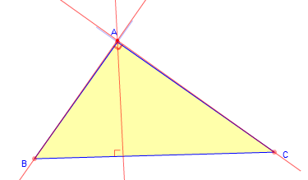
The _______________________ is the point where the 3 _______________________ intersect.
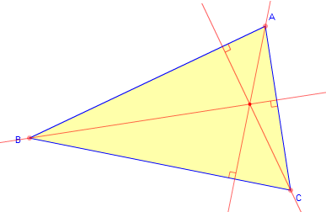

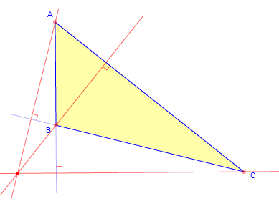

Equilateral Triangle

Points of Concurrency
The _______________________ is the point where the 3 _______________________ intersect.
The centroid is always inside the triangle. It is the “center of gravity” of the triangular region.
Centroid Conjecture: The centroid of a triangle divides each median into two parts so that the distance from the centroid to the vertex is ______________________ the distance from the centroid to the midpoint of the opposite side.
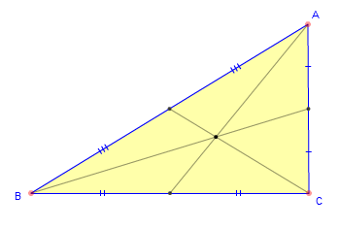
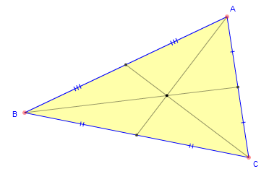

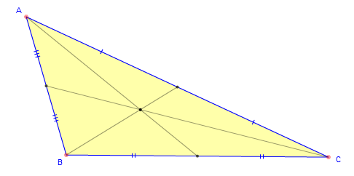

Equilateral Triangle

Circumscribed Circle
A circle is _______________________ about a polygon if and only if it passes through each vertex of the polygon. (The polygon is inscribed in the circle.)
The ___________________ is the center of a circumscribed circle.
Constructing a circle circumscribed about a triangle
- Draw any ∆ABC

- Construct perpendicular bisectors from 2 different sides

- Label the point of concurrency, pt D (circumcenter)

- Open the width of the compass from the circumcenter to a vertex (This is the radius for your circle)

- Draw a circle around the outside of the triangle. It should touch all three vertices.

Inscribed Circle
A circle is _______________________ in a polygon if and only if it touches each side of the polygon at exactly one point. (The polygon is circumscribed about the circle.)
The ___________________ is the center of an inscribed circle.
Constructing a circle inscribed in a triangle
- Draw any ∆ABC

- Construct angle bisectors from 2 different vertices

- Label the point of concurrency, pt D (incenter)

- Construct a perpendicular from point D to one of the sides.

- Label that point E

- Adjust the width of your compass from point D to point E (This is the radius for your circle)

- Draw a circle inside the triangle. It should touch all three sides.

Constructing Parallel Lines
Constructing Parallel Lines
- Draw a line and label two points on the line. (points P and Q)
- Label a point off of the line. (Point R)
- Connect the point off the line with a new point on the line. Label the new point. (Point J)
- Open the compass about half the distance of your segment from part 3 and draw an arc across both lines. (do not change the width of the compass)
- Using the same compass width as part 4, move the compass to Point R and draw the same arc as step 4.
- Open the compass to the width of where the lower arc crosses the two lines.
- Move the compass to where the upper arc crosses the line and draw and arc across the upper arc, forming Point S.
- Connect Point R to Point S
- Parallel lines have been created

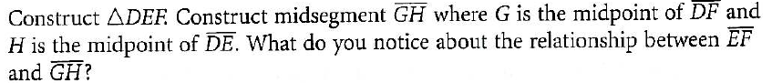

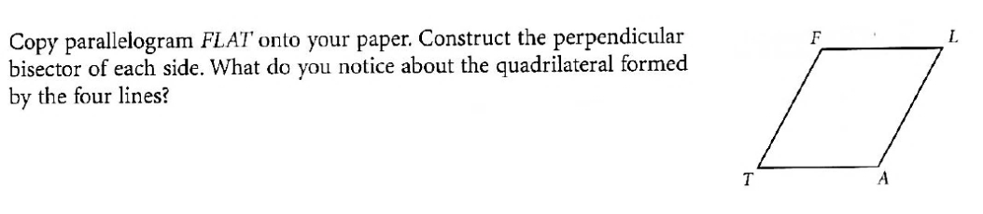

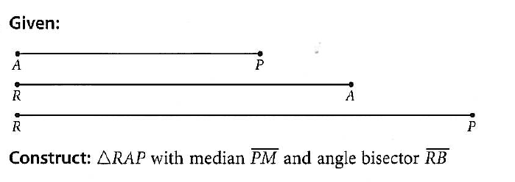

More Constructions Practice
House
The Jones’ Lot
House
- This rectangle represents the Jones’ lot. The triangular region represents their backyard. The Jones’ want to build the largest possible circular pool in the back yard. What point of concurrency would help you determine the location of the pool?

- The Smith Construction Company has been hired to install a new water fountain at Winstonian Park. They would like to find the best location for the fountain so that the walking distance from each of the three main pieces of playground equipment is the same. What point of concurrency would the construction company need to find and explain how you determined this?
Merry-go-round
Swing
See-Saw

- You are a sculptor and have just completed a large metal mobile. You want to hang this mobile, made of a flat triangular metal plate, in the State Capitol. This triangular piece will hang so that it will be suspended with the triangular surface parallel to the ground. What point of concurrency would the sculptor need to find? Explain how you determined this.

- The first-aid center of Mt. Thermopolis State Park needs to be at a point that is equidistant from three bike paths that intersect to form a triangle. What point of concurrency should be found so that in an emergency medical personnel will be able to get to any one of the paths by the shortest route possible?

- Julian Chive wishes to center a butcher-block table at a location equidistant from the refrigerator, stove and sink. Which point of concurrency does Julian need to locate? Explain how you know.

- Rosita wants to install a circular sink in her new triangular countertop. She wants to choose the largest sink that will fit. Which point of concurrency must she locate? Explain how you know.

- Birdy McFly is designing a large triangular hang glider. She needs to locate the center of gravity for her glider. Which point of concurrency does she need to locate? Explain. Birdy wishes to decorate her glider with the largest possible circle within her large triangular hang glider. Which point of concurrency does she need to locate? Explain.

- A stained-glass window artist wishes to circumscribe a circle about a triangle in her latest abstract design. Which point of concurrency does she need to locate? Explain how you know.

- Construct line AB parallel to line CD

- Construct a large acute triangle, then construct an angle bisector from one vertex, a median from one vertex and an altitude from the third vertex.

- Construct trapezoid TRAP with segment TR parallel to segment AP.

- Draw a large triangle. Construct a circle inscribed in the triangle and a circle circumscribed about the triangle.

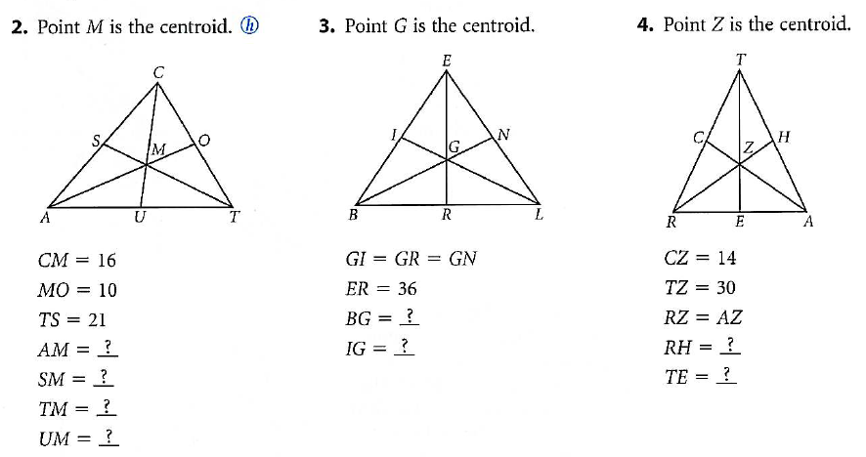
- Answer the following about centroids.

