**Section 6.1 – Law of Sines Name: ________________________**

Completed Notes at: <http://bit.ly/2zl3w0O>

Goal of the Lesson : _________________________________________________________________________  
  
Extra emphasis on: _________________________________________________________________________

During the first semester, we solved triangles (found all the missing side lengths and angle measures) for right triangles. Because they were right triangles we could use inverse SOHCAHTOA to find angle measures, Pythagorean Theorem to find missing side lengths, and SOHCAHTOA equations to also help us find side lengths. The restriction on all of these tools was that they required right triangles.  
  
In section 6.1 (law of sines) and section 6.2 (law of cosines), we will not be restricted to right triangles but it also means that we can’t use SOHCAHTOA or Pythagorean Theorem like we could before.

----------------------------------------------------------------------------------------------------------------------------------------------------------------

***What:* *The Formula for the Law of Sines:***

***When:*** Looking at the formula, you should see that in order to use it you will need two angle measures and a side length or two side lengths and an angle measure. **ASA or AAS or SSA**

Comparing ASA and AAS:

(Video that compares the difference between ASA and AAS: <http://bit.ly/2B9cvF1> length: 2:39)

(Recall from Geometry) The Theorems that prove triangle congruence: SSS, SAS, ASA, AAS, HL.  
 - Therefore the ASA and AAS conditions of the Law of Sines will always “just work” without us worrying about other possible solutions/conditions.

***How to find side lengths:*** The ASA and AAS cases (the ones that just work).

1. If , , and a = 10. 2. If , , and c = 127.  
   find the length of b. find the length of b.

A quick way to determine if your answers are realistic is to make sure the bigger side lengths are opposite the larger angle measures.

1. If , , and a = 10. 4. If , , and c = 127.  
   find the length of c. find the length of a.

(Video example: <http://bit.ly/2kH4cVG> length: 2:39)

----------------------------------------------------------------------------------------------------------------------------------------------------------------

(Recall from Geometry) The Theorems that prove triangle congruence: SSS, SAS, ASA, AAS, HL.  
 - However, SSA does not guarantee a unique triangle and multiple possible conditions exist. This case is referred to as the “Ambiguous Case”.

**The Ambiguous Case:**

Depending on the size of the given angle, and the lengths of the two given sides, you may not be guaranteed one unique triangle. You may get 0 possibilities, 1 unique triangle possibility, or even 2 possible triangles. You need to know how to determine how many triangles can be made given the lengths and measures.

* 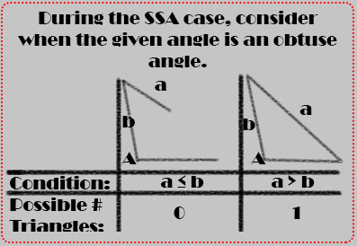**If the given angle is obtuse,**  
  then you can have either one possible triangle  
  (the numbers given to you from the law of sines   
  are the correct measurements) or no possible   
  triangles:

1. If , b = 25, and a = 15. How many possible   
   triangles can be made from these numbers? _____   
   What are the possible measure(s) of B? _________
2. If , b = 10, and a = 15. How many   
   possible triangles can be made from these   
   numbers? _____  
   What are the possible measure(s) of B? __________

7. If , b = 2.75, and a = 3.25, 8. If , b = 9.9, and a = 6,   
How many possible ∆s can be made? ________ How many possible ∆s can be made? ________  
What are the possible measure(s) of B? _________ What are the possible measure(s) of B? _________

----------------------------------------------------------------------------------------------------------------------------------------------------------------

* **If the given angle is a right angle,**  
  then you can use SOHCAHTOA from last semester:

9. If , b = 19.7, and a = 25.8, 10. If , b = 3, and a = 5,   
How many possible ∆s can be made? ________ How many possible ∆s can be made? ________  
What are the possible measure(s) of B? _________ What are the possible measure(s) of B? _________

----------------------------------------------------------------------------------------------------------------------------------------------------------------

* **If the given angle is acute,**  
  then you can have either one possible triangle (the numbers given to you from the law of sines   
  are the correct measurements), no possible triangles, or even two possible triangles ((the numbers given to you from the law of sines for one angle, and its supplement for the other possibility):

For this case, we need to compare the length of the side opposite the given angle (which we will refer to as the swinging side) to the height of the triangle. Since the height of the triangle will always have a right angle, a SOHCAHTOA equation quickly tells us it would be h = bsinA.

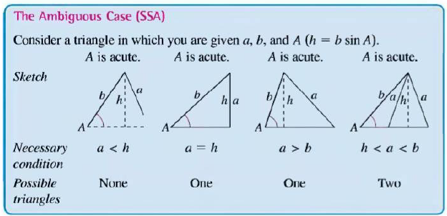

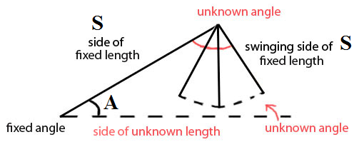

***Determining how many triangles are possible under the SSA (ambiguous case) given an acute angle:***

11. If , b = 29.3, and a = 20, 12. If , b = 17, and a = 15,   
How many possible ∆s can be made? ________ How many possible ∆s can be made? ________  
Sketch: Sketch:

13. If , b = 10, and a = 5, 14. If , b = 100, and a = 95,   
How many possible ∆s can be made? ________ How many possible ∆s can be made? ________  
Sketch: Sketch:

15. If , b = 28.9, and a = 2, 16. If , b = 78, and a = 39,   
How many possible ∆s can be made? ________ How many possible ∆s can be made? ________  
Sketch: Sketch:

17. If , b = 5, and a = 3.5, 18. If , b = 26, and a = 17,   
How many possible ∆s can be made? ________ How many possible ∆s can be made? ________  
Sketch: Sketch:

(Video examples: <http://bit.ly/2BsSXrU> length: 5:13)

***How to find angle measures:*** The SSA case.

* If the given measurements can’t be used to create a triangle, then there is no point in finding the measure of B as it won’t exist anyways.
* If the given measurements result in one possible triangle, then we use the law of sines formula and can solve for that one possible value of B.
* If the given measurements result in two possible triangles, then we use the law of sines formula to find the first possible value for B. The second possible value for B will be the supplement of the other.

19. If , b = 17, and a = 13, 20. If , b = 100, and a = 50,   
How many possible ∆s can be made? ________ How many possible ∆s can be made? ________  
Possible angle measure(s) for B: _______________ Possible angle measure(s) for B: _______________

21. If , b = 45, and a = 45, 22. If , b = 20.5, and a = 19,   
How many possible ∆s can be made? ________ How many possible ∆s can be made? ________  
Possible angle measure(s) for B: _______________ Possible angle measure(s) for B: _______________

23. If , b = 47, and a = 23.5, 24. If , b = 19, and a = 5,   
How many possible ∆s can be made? ________ How many possible ∆s can be made? ________  
Possible angle measure(s) for B: _______________ Possible angle measure(s) for B: _______________

25. If , b = 17, and a = 13.5, 26. If , b = 990, and a = 495,   
How many possible ∆s can be made? ________ How many possible ∆s can be made? ________  
Possible angle measure(s) for B: _______________ Possible angle measure(s) for B: _______________

***Solving Triangles: (finding all the side lengths, and angle measures)***

* You can still use the fact that all angles add up to 180 degrees as this is true for all triangles
* You can’t use SOHCAHTOA or Pythagorean Theorem unless it is a right triangle.
* You can use Law of Sines when you have ASA, AAS, or SSA.

27. Solve the triangle(s) where, 28. Solve the triangle(s) where,   
, b = 27.4, and . a = 12, b = 25, and .

----------------------------------------------------------------------------------------------------------------------------------------------------------------

**Finding area of an Oblique Triangle (not a right triangle):**

* **Formula from Geometry: 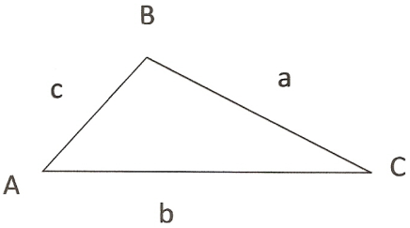 Area = _______________________**
* **Same formula but using different information (no height given, but we can find with SOHCAHTOA equation)**

**   
  
  
h = h = h =  
  
Area = ___________________ = _____________________ = _____________________ = _____________________**(Video example: [**http://bit.ly/2jb3EqJ**](http://bit.ly/2jb3EqJ) length: 4:06)